The Wedding Ceremony
Joining in Marriage
Brette & Nate

Oct. 27, 2012
Sarasota, FL

Rev. Dr. Toni LaMotta,
Officiating Minister

CONVOCATION -:
We are gathered here today to witness the coming together of two people, Brette and Nate whose hearts and spirits are entwined as one. They now desire to profess before all the world their intention to walk the road of life together. Nate and Brette have come to make official and public their love and commitment to live and grow together as husband and wife.
Loving is the ultimate commitment which challenges humans to become all that we are meant to be.
As they join in marriage today, Nate and Brette are announcing to all that they are welcoming that challenge.
We rejoice with them on this special day.

Opening Poem/Reading:
The Art of Marriage
By Wilferd A. Peterson
The little things are the big things.
It is never being too old to hold hands.
It is remembering to say "I love you" at least once a day.
It is never going to sleep angry.
It is at no time taking the other for granted;
the courtship should not end with the honeymoon.
It should continue through all the years.
It is having a mutual sense of values and common objectives.
It is standing together facing the world.
It is forming a circle of love that gathers in the whole family.
It is doing things for each other,
not in the attitude of duty or sacrifice,
but in the spirit of joy.
It is speaking words of appreciation and demonstrating gratitude in thoughtful ways.
It is not expecting the husband to wear a halo or the wife to have wings of an angel.
It is not looking for perfection in each other.
It is cultivating flexibility, patience,
understanding and a sense of humor.
It is having the capacity to forgive and forget.
It is giving each other an atmosphere in which each can grow.
It is finding room for the things of the spirit.
It is a common search for the good and the beautiful.
It is establishing a relationship in which the independence is equal,
dependence is mutual and the obligation is reciprocal.
It is not only marrying the right partner,
it is being the right partner.

TONI: Nate and Brette, You have chosen each other as partners in life’s journey. Are you ready to be married? If so, please say, WE ARE.
Brette and Nate: WE ARE

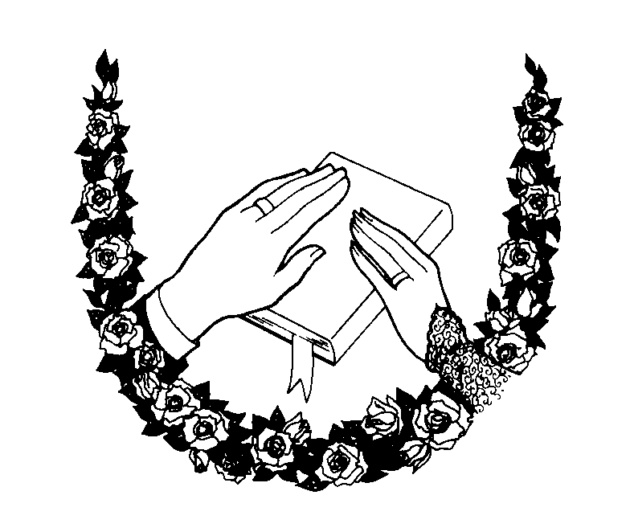
I invite you now to exchange your vows.

Exchange of Rings:

Do you Nate take Brette to be your lawfully wedded wife, love and cherish, for better or for worse, from rags to riches and back again, though sickness and in health, faithful partner and best friend from this day forward.

Groom: “I Do”

Wear this ring forever, Brette, as a symbol of love and peace and of all that is unending.
(ring goes on Brides finger)

Do you Brette take Nate to be your lawfully wedded husband, love and cherish, for better or for worse, from rags to riches, though sickness and in health, faithful partner and best friend from this day forward.

Bride: “I Do”
Wear this ring forever, Nate, as a symbol of love and peace and of all that is unending.
(ring goes on Grooms finger)
CLOSING BLESSING:
At this moment as you are about to begin your life together as husband and wife, I give thanks for the opportunity to bless you Nate and Brette and I also would like to add a special blessing to include Jake as you begin your time together officially as a family. The greatest gift you can give to Jake is your love for each other. And I know that a greater love is assured in this world because of the commitment you have made here today. And so I say, Thank you, God. Thank you, Nate. Thank you, Brette.
PROUNOUNCEMENT
AND NOW. . .I recognize with full awareness that only a couple can administer the sacrament of marriage to each other; and only a couple can sanctify it. Neither my church, nor any power vested in me by the state, can grant me authority to declare what only two hearts can declare and what only two souls can make real.
So now, in as much as you, Nate and you, Brette have announced the truths that are already written in your hearts, and have declared the same in the presence of these witnesses I observe joyfully that you have declared yourselves to be husband and wife.

You may kiss one another,
May I now present to you:
Mr. & Mrs Brette & Nate Egan

